UNIT 3 SPEAKING
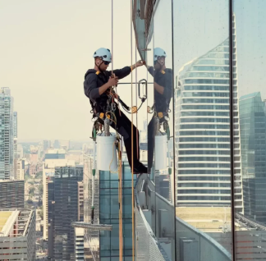
- Look at the photo. What’s the man’s job? Do you think he enjoys it? Why / Why not? Would you like to do it?

- Read the quote. Is this true for you or anyone you know?
‘Choose a job you love and you will never have to work a day in your life.’ Johann Wolfgang von Goethe
- How do you begin your day? What’s your early morning routine?
- Which of the following jobs do you think are most/least stressful? Why? Which would you most/least like to do? Why?
football manager / head teacher / deep-sea diver /oil-well installer / A&E doctor
- Do you agree that staff work harder if they have less stress?
- Is there ‘income inequality’ in your country? Give examples.
- What do you do when you’re not studying? Make a list of what you do in your free time. Who do you do it with? Where?
- When do we make small talk? Who with? What about?

